**KWAME NKRUMAH UNIVERSITY OF SCIENCE AND TECHNOLOGY**

**(KUMASI)**

**COLLEGE OF SCIENCE**

**DEPARTMENT OF COMPUTER SCIENCE**



# PROJECT TITLE: FAST-FOOD WEB SELF SERVICE MACHINE.

THIRD YEAR MINI PROJECT

**ANTWI RAYMOND ABOAGYE**

**INDEX NUMBER: 4195820**

**SUPERVISOR:** **DR. ERIC OSEI**

**DATE: 15TH AUGUST 2023**

### EXECUTIVE SUMMARY

The Fast-food Self-Service Web App project aims to enhance customer experience by introducing a user-friendly digital platform for ordering and customizing meals. This initiative responds to contactless dining solutions and collection of customer insights for menu optimization. By offering real-time updates and menu personalization, wait times are reduced and order accuracy improved.

### PROJECT BACKGROUND AND PROBLEM STATEMENT

**Problem Statement:**

The traditional manual order in our fast-food chain led to extended wait times, errors in fulfilment and lack of personalization options.

**Project Background:**

In response to evolving consumer preferences and the need for streamlined dining experiences, this project focuses on creating a Fast-food self-service web application. This app aims to tackle the challenges posed by lengthy queues, order inaccuracies and the demand for contactless dining options. By leveraging technology, this aims to enhance customer satisfaction and operational efficiency.

### PROJECT OBJECTIVE

The Fast-Food Ordering Service Machine Web App aims to provide a convenient platform for customers to order food items from a fast-food restaurant. The web app presents an interactive menu with various food options with their respective prices. Customers can customize their orders and add items to their cart. The app also supports secure payment processing for seamless transactions.

## METHODOLOGY

### Architecture Overview:

The web app follows a client-server architecture, where the front-end is developed using HTML, CSS, JavaScript, and Vue.js

### Development:

The front-end is responsible for the user interface and interactions. Vue.js is used as the primary front-end framework for building interactive components and managing state.

### Technologies Used:

The Fast-Food Ordering Service Machine Web App is built using the following technologies:

* HTML
* CSS
* JavaScript
* Vue.js

### Features:

1. Browsing Menu: Users can explore the menu with different categories (e.g., burgers, drinks, desserts) and view detailed information about each item.
2. Placing Orders: Customers can add items to their cart, specify customizations

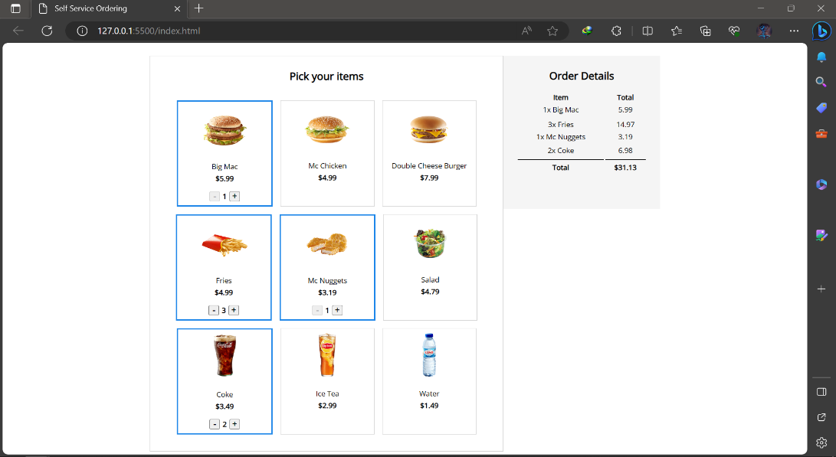

## TESTING

### Unit Testing:

The components are individually tested to ensure their functionality meets the requirements.

### User Acceptance Testing:

The web app is tested with actual users to ensure it meets their expectations and is user-friendly.

**RESULTS**

* **Faster Service:**

Wait times during peak hours will significantly decrease as customers can effortlessly place orders.

* **Accurate Orders:**

Customization features have reduced order inaccuracies, improving customer satisfaction.

* **Data Insights:**

Data collection has provided valuable insights for menu adjustments and promotions.

* **Operational Efficiency:**

The app’s self-service model meets the demand for safe and convenient dining.

* **Competitive Edge:**

This app embraces innovation and serves as customer-centric in the market.

## CHALLENGES AND TROUBLESHOOTING

* Login/Registration problems
* Menu not loading or displaying incorrectly
* Issues with placing or completing orders

**CONCLUSSION**

The Fast-food Self-service Web app project has successfully modernized our operations, improved customer satisfaction and set the position as a tech-savvy industry leader. It has also reduced wait times and enhanced order accuracy.

As we move forward, the app will remain instrumental in maintaining operational efficiency, engaging customers, and sustaining our competitive edge in the dynamic fast-food landscape.

## USER GUIDE

### Browsing Menu:

1. You will be redirected to the menu page.
2. Browse the different food categories and click on an item to view its details.
3. Customize the item and click "Add to Cart" to add it to your order.

### Placing Orders:

1. Ensure your cart contains all the items you want to order.
2. Review the items in your cart and make any necessary changes.

## FUTURE ENHANCEMENTS

### Additional Features:

* Add real-time chat support for customer inquiries.
* Introduce login/signup forms and account controls.
* Integration of secured payment options

### Performance Improvements:

* Optimize loading times for the web app.
* Implement caching mechanisms to reduce server requests.
* Enhance the back-end for scalability during peak times.

**REFERENCES**

* Google images
* Vue.js library
* <https://fonts.googleapis.com>